Invitation to Bid to Operate the Belle Vue Café in Belle Vue Park, Sudbury

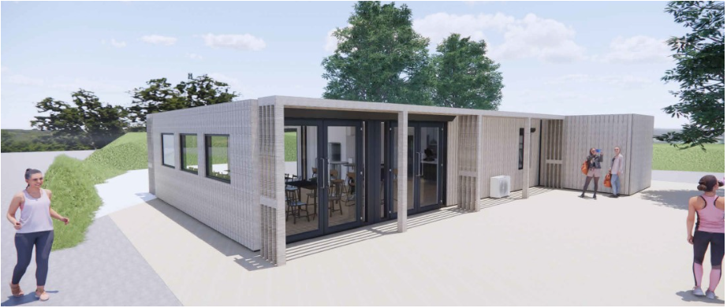

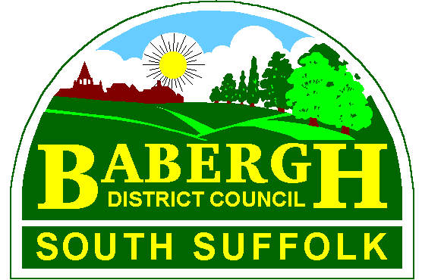

Prepared by:

Babergh District Council
Endeavour House
8 Russell Road
IPSWICH
Suffolk
IP1 2BX

Contents
Contents 2
1. Introduction and Background 4
1.1. Summary: 4
Belle Vue Café 5
Town Centre 5
1.2. Invitation to Bid: 5
2. The Proposed Café 6
3. Bid Process 7
3.1. Timings and Process: 7
3.2. Evaluation and Award Criteria: 7
4. Conditions of Bid 8
4.1. Completion of Bid Documents: 8
4.2. Timetable and Specified Deadlines: 9
4.3. Collusion: 9
4.4. Confidentiality: 9
4.5. Inducements: 9
4.6. Agreement Implementation: 9
4.7. Insurance: 10
4.8. Sub-Contracting and Assignment: 10
4.9. Delivery of Responses: 10
4.9.1. Delivery by Post: 10
4.9.2. Delivery by E-mail: 10
5. Informal Tender Bids for Lease 11
5.1. Opening Hours: 11
5.2. Additional Opening Hours and Park Events 11
5.3. Style of Service: 11
5.4. Café Facilities, Equipment and Furniture: 12
5.5. Minimum Food and Beverage Offer: 12
5.6. Tariff and Payment: 12
5.7. Marketing: 13
5.8. Future Vision: 13
5.9. Housekeeping, Security and Ethos: 13
6. Financial Requirement 13
6.1. Capital Investment: 13
6.2. Utilities and Services: 14
6.3. Concession: 14
6.4. Performance: 14
7. Submission Response 14
Appendix A – Heads of Terms for Lease: 16

Introduction and Background

Summary:

Babergh District Council (the “Council”) is installing a new modular construction café and public convenience block (incorporating a changing place standard accessible unit) at Belle Vue Park in Sudbury town centre. Operational from early Summer 2024, this exciting new facility within the historic park setting will cater for visitors and residents alike. The Council is seeking innovative proposals from potential tenants who have a desire to help build an inclusive park community and deliver wider social value to the town.

This investment will complement and enhance the range of activity and play upgrades programmed for the park over the next few years.

The site is located in Sudbury, a market town in Suffolk, near to the Essex border. Sudbury retains its status as a historic market town with twice-weekly markets within the town centre in front of the Grade I listed St Peter's Cultural Venue, which is now a local community point for events such as concerts and exhibitions as well as a local landmark.
This park is a real hidden gem, within the centre of Sudbury which covers an area of 5.4 acres including swathe of green space and formal gardens. The park is suitable for play, walking, fitness and family activities and features sports facilities such as a basketball court, a tennis court, skate park and playgrounds including sandpit and adventure climbers. A range of local groups and volunteers support the park including Activlives who run several 'Grow Your Future' programmes for anyone aged 16+ who are unemployed or economically inactive, and not engaging in education or training.
Belle Vue Park is located in the centre of Sudbury with its main entrance accessible from Newton Road, and a secondary access from Ingrams Well Road. A short 5-minute walk from Sudbury train station, the bus station and with ample free and low cost town parking nearby on Great Eastern Road / Station Road. The Council is also seeking options to incorporate new blue badge parking spaces near to the Newton Road park entrance, within a short distance of the new changing place facility.

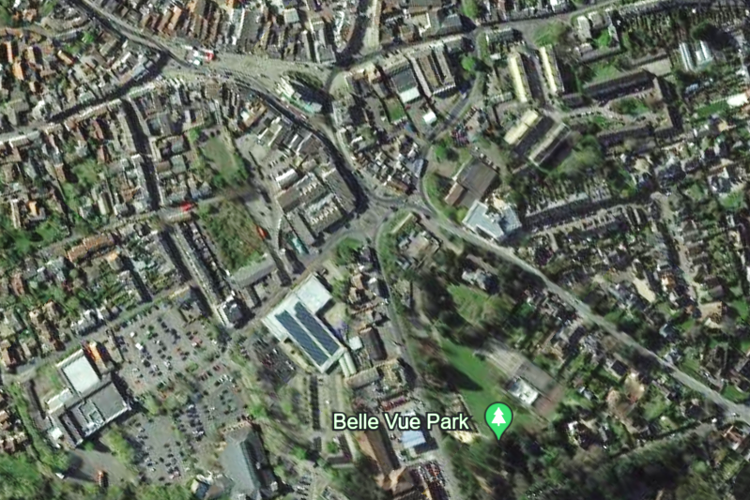

Belle Vue Café

Town Centre

Invitation to Bid:

The Council is seeking a café operator who can demonstrate a strong commitment to adding social value through a range of activities which encourage or promote opportunities for improving economic, social and environmental well-being within the locality, including for the groups of younger people who use the park. We seek to build an inclusive community within the park and see the café and its operation as being an integral and progressive part of achieving this for the longer-term.

The operator will be responsible for keyholding for the changing place unit and contribute actively in the supervision, security and monitoring of activity within the wider park, and as an effective partner to the district and town councils who organise events, activities and undertake maintenance and improvements to the park. Although open to bidder proposals, it is the Council’s expectation that the operator will be responsible for daily monitoring, cleaning and supplies of the toilets linked to the café (but separately accessible from outside) and this should include provision of toilet paper, soap, sanitary items etc.

For Rent / Concession the Council is asking bidders to make an offer for the rental level and the % concession, hence these are blank for bidders to make their proposals within the Heads of Terms (Appendix A). It should be made clear within the body of the bid proposals what the operator proposals are in relation to day-to-day cleansing and supplies of the WC units.

Bid responses shoud support a financially viable operation (for both parties) of the Belle Vue Café, whilst providing an excellent customer experience for our visitors and local people who are contributing to the growth and vibrancy of the town centre.

The café and enhanced toilet and changing facilities are part of a package of park improvements planned for the next few years to drive up awareness, activity and use of this much loved community park. The investment in this facility is a significant commitment from the district council towards making the park better and more accessible for users of all ages whether they are taking their children for a play, socialising with friends, undertaking activity or sports, using outdoor space they don’t have where they live or simply enjoying the open green space, fresh air and historic setting. We want to secure the right operator to help on this journey and bring about increased benefits to the town.

The Proposed Café

The current design proposals for the Café envisage a premise of some 120 m² internal space, plus external seating area.

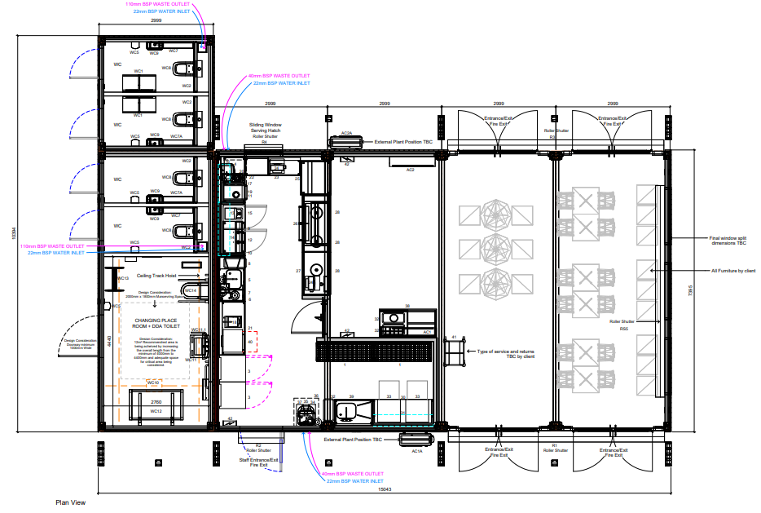
Figure 1: proposed floorplan for the cafe

This space will comprise of:

- A café to accommodate kitchen facilities as opposed to a full cook kitchen
- 3-phase electricity supply availability
- Overall café footprint allows for 15-20 covers inside and 20-30 covers outside
- Ability for view across the park, a restored Belle Vue House (under development) and play areas. Close proximity and views towards a new reconfigured under-5s play area is of high importance
- Toilet facilities should comprise male/female/standard accessible and higher specification Changing Place format
- WCs are to be accessed independently of the café, with access controlled from the café to the changing place unit
- A contemporary and sensitive finish which works well in the park setting and given its prominence to the town, a restored Belle Vue House and being in the vicinity of the town centre conservation area
- Simple and cost-effective design solution of robust and secure design to reduce impact / occurrence of vandalism / fear of crime and anti-social behaviour
- The proposal is to consider sustainable design and building orientation to maintain benefits of sightlines, natural light and solar PV micro-generation from the rooftop panels (likely to generate over 4,500 kW hours per annum)

Bid Process

The Council is proposing to offer the successful bidder a maximum 10-year lease (based upon the Heads of Terms set out in Appendix A) to operate and manage the Café.

The closing date for bids is 1:00pm on Monday 4th March 2024.

Timings and Process:

The bid timetable provided below is indicative and the Council reserves the right to make changes if necessary.

Bid documents available | Friday 12th January 2024
Formal applicant visits to the site and view plans of the proposed facility | ^{w}/_{c} 29th January 2024 &  ^{w}/_{c} 19th February 2024
Deadline for the submission of Bids | 1:00pm, Monday 4th March 2024
Shortlisting of applicants on | Tuesday 5th March 2024
Interviews of shortlisted applicants | ^{w}/_{c} 11th March 2024
Confirmation of award | ^{w}/_{c} 18th March 2024
Completion of the facility and hand over to tenant for fit out | Early Summer 2024

Bidders can view plans and drawings of the proposed Belle Vue Café on the planning portal (Application Ref: DC/23/05003) at https://www.babergh.gov.uk/w/application-search-and-comment

Evaluation and Award Criteria:

The Council will grant a Lease to the successful bidder. As stated in paragraph 1.2 above, the Council is seeking innovative concepts for running the café and is particularly seeking those activities which fit within the Sudbury vision https://heartofsuffolk.co.uk/invest/town-centre-development/sudbury/ and wider visitor economy.

The successful bidder must be able to:

- Produce an Income Statement that provides an estimate of the first three year’s income and costings, together with a management plan;
- Illustrate its concept and future vision for the Café in a business model; and
- Demonstrate their experience at managing similar facilities or running a business in the catering industry.
The bids will be assessed for compliance and those assessed and scored over 60% will be invited to an interview. The interview will be assessed on a presentation covering:
The vision and business model for the café (40%)- criteria
- Strong vision with excellent customer experience for the visitors and local people and contributing to the economy of Sudbury
- Strong commitment to social values through a range of activities (including for young people) that encourage or promote opportunities for the economic, social and environmental well-being of the locality

Finance (20%) - criteria
- Ability to supply all equipment, white goods, furniture, crockery, cutlery and other chattels (where not already included in the building specification)
- Forecasting for the next three years
- Financing for the kitchen fit (note: kitchen is not a full cook kitchen)
- Rent projection and concession % estimate

Café offer (20%) - criteria
- Open all year with the potential to facilitate evening events
- High quality service and value to the visitor’s experience with friendly, helpful and considerate staff and make the customer feels welcome
- Delivering attractive but affordable food
- Food offer – children’s meals with healthy options and half adult portions; range of healthier foods; provision for specific diets; seasonality and locally sourced where possible

Social value (20%) - criteria
- Strong environmental and sustainable operation ethos
- Community events and being active in the community
- Focus on engaging with young people
- Employment opportunities

Conditions of Bid

Completion of Bid Documents:

It is the responsibility of the bidder to ensure that they have read and understood all the documentation included in the package. Bidders must satisfy themselves as to the accuracy of any and all information.

Bidders are responsible for ensuring that they have completed the bid fully and accurately and that the prices quoted are arithmetically correct. Amendments to the bid will not be permitted after submission, unless explicitly requested by the Council.

All costs, including travel and associated costs, incurred in relation to this bid preparation are to be borne by the bidder.

Bids must be submitted on the basis requested in the bid document. Additional alternative offers may be considered (at the sole discretion of the Council) and should be submitted separately.

The evaluation of bids is not solely based upon financial consideration; therefore, the Council does not undertake to accept the bid that offers the highest potential concession income.

Timetable and Specified Deadlines:

The Council intends to follow (as far as is reasonably practicable) the timetable, detailed in Section 3 above, in performing the evaluation and selection process to allow the Council sufficient time for analysis, selection, implementation and communication of the selected bidders.

It is the Council's intention to respond to all reasonable requests for additional information and to reasonably co-operate with the bidders in the development of their proposal.

The Council will reject any bid which is received later than the deadline for the bid return (1:00pm, Monday 4th March 2024) or does not fully comply with stipulated requirements.

The Council will notify bidders whether they have been successful or unsuccessful. The dates are subject to change at the discretion of the Council.

Collusion:

Bidders must not submit an offer in collusion with any other person, company or body, which may have the effect of distorting or decreasing the consideration for the Café offered.

Any bidder who:

(i) fixes or adjusts the amount of his bid by or in accordance with any agreement or arrangement with any other person; or
(ii) communicates to any other person other than the Council the amount or approximate amount of his proposed bid; or
(iii) enters into any agreement or arrangement with any other person that he shall refrain from bidding; or
(iv) offers or agrees to pay or give or does pay or give any sum of money, inducement or valuable consideration directly or indirectly to any person for doing or having done or causing or having caused to be done any act or omission in relation to any other bid or proposed bid for the Café

will (without prejudice to any other civil remedies available to the Council and without prejudice to any criminal liability which such contact by a bidder may attract) be disqualified.

Confidentiality:

Any material of a confidential nature, submitted by a bidder, should be clearly marked as confidential. All material provided by the Council, in relation to this bid, must be treated as confidential.

Inducements:

The Council has a strong belief in propriety and ethics. Any bidder attempting to offer any inducement to a member of staff or Council Member will be excluded from the bidding process.

Agreement Implementation:

The successful bidder will be required to enter into a Lease with the Council under terms and conditions agreed in the Heads of Terms set out in Appendix A.

Insurance:

The successful bidder will be required to maintain public and employers liability insurance as set out in the Heads of Terms in Appendix A.

Sub-Contracting and Assignment:

Bidders should note that restrictions pertaining to assigning, subletting and/or sharing occupation of the whole or any part of the Lease Area are contained in the Heads of Terms in Appendix A.

Delivery of Responses:

Bid documents, covering letters and accompanying information can be sent either by post or email as detailed below, but should not be duplicated by sending using both methods. It is the bidders responsibility to ensure safe delivery by the bid closure date/time specified.

Delivery by Post:

The bid submission and supporting information must be sent, along with a supporting statement of bid signed by an authorised representative of the bidder within the same envelope. The envelope or package should be marked “Belle Vue Park Café”.

Bidders are advised to submit bids by recorded delivery, registered mail or by hand. Regardless of method chosen, delivery shall be entirely at the bidder’s risk.

The Heads of Terms must be completed (entries made in those spaces coloured yellow) and signed and included in the envelope.

The bid and accompanying documents must be addressed to or delivered to:

Babergh District Council,
For the attention of: Mr L Carvell (Regeneration Team)
Endeavour House,
8 Russell Road,
Ipswich,
Suffolk
IP1 2BX

not later than 1:00pm, Monday 4th March 2024. Bids must remain valid for at least 90 days. Otherwise, the bid envelope should not bear any information identifying the name of the sender.

Delivery by E-mail:

As an alternative to hard copies, bidder’s and a company information and covering letters can be sent via email to regeneration@baberghmidsuffolk.gov.uk not later than 1:00pm, Monday 4th March 2024.

The e-mail subject title should read “Belle Vue Park Café”

The Heads of Terms must be completed (entries made in those spaces coloured yellow) and signed and a PDF copy attached to the e-mail. For the avoidance of any doubt, the Council is expecting bidders to submit their own proposals on rental levels and concession % on GROSS annual sales – hence why these are left blank and highlighted. The rest of the bid detail should make clear the bidder proposals relevant to the operation including extent of toilet supervision / supplies.

Informal Tender Bids for Lease

Opening Hours:

We are seeking bids that enable the Belle Vue Park Café to be open all year; hours to be agreed. Ordinarily this will be within the wider park opening times / seasonality.

Additional Opening Hours and Park Events

The Café may open outside of the hours given above if the successful bidder feels that there is a business (or social / community value) opportunity, subject to planning permission and Landlord’s consent, to facilitate evening events. The Council would like to see/support evening events.

When events are hosted in the park, the café operator will normally be given first refusal to cater for the event. It is the expectation that the café will be open for business during events at the park even where other caterers and refreshment outlets are on site for the duration of an event (for example ‘Party in the Park’).

It should be noted that a full permanent Licensing Act 2003 premises licence number BPL0322 (regulated entertainment only, no alcohol authorisation) is in effect for events at Belle Vue Park and that any temporary alcohol licence required should be applied for via the Temporary Events Notice (TENS) system. Any intention by the café operator to supply alcohol shall be advised to the Council by the operator not later than 14 days before any such activity. The Council shall not normally withhold its consent for such applications or notices unless it is reasonably necessary to safeguard one or more of the licensing objectives.

Style of Service:

The level of service must reflect the high-quality setting and prominence of Belle Vue Park and add value to the visitors’ experience. Friendly, helpful and considerate staff are required to offer great catering service and make the customers feel welcome and want to return again.

The café must be well run with a strong reputation for delivering an attractive but affordable food offer with clear menus and pricing.

The café is integral to the vision for the wider park so strong commitment to work in partnership for the benefit of the wider park and groups and volunteers which use it, is essential. The Council’s ambition is for the facility to be more than a café and to run and be a hub for community events, including a focus on young people.

In keeping with the Council’s strong commitment to carbon reduction, we would expect all equipment and consumables within the facility to be ethically sourced and sustainable with minimised use of items such as single use plastics for example paper straws rather than plastic and minimal food packaging. All washable crockery and cutlery must be of a high quality and fit for purpose and single use items should only be provided for takeaway products.

The café operator will need to separate, store and facilitate collection of both non-recyclable waste and recyclate and provide lidded bins both inside and outside of the café and immediate vicinity. Food and beverage containers and other litter shall be regularly collected by the operator and disposed of appropriately including recyclable materials.

The Council has set some some reasonable performance and monitoring indicators to support its expectations for the operation of the café. These are considered proportionate and not overly onerous, and will support discussions on management of the café/toilets and progressing the wider community benefits achievable.

Café Facilities, Equipment and Furniture:

Under the terms of the Lease (see Heads of Terms in Appendix A), the tenant shall be responsible for fitting out the cafe including all kitchen equipment and any white goods/furniture etc. It should be noted that the base build specification does already include some kitchen equipment (see Equipment Schedule on the layout drawing). The Council will work with the preferred tenant through the development process to agree timescales and level of fit out required for the facility however priority must be given to ensuring access for all is provided in the finished building.

The Council will consider granting a rent free period to assist the successful bidder with fit out requirements but any proposals must include the level requested and financial justification.

Outdoor tables and seating immediately outside the café for daily operation use shall be provided and maintained by the operator and stored securely inside the premises when not in use. Any permanent/fixed outdoor seating and furniture as part of the wider park will be funded/provided by the Council in consultation with its Public Realm team and in view of the wider play activity refresh programme.

Minimum Food and Beverage Offer:

The successful bidder will have demonstrated the ability to cater for the needs to a range of visitors and to ensure that the food and beverages on offer are both appropriate and appealing. As a minimum, the following should be considered:

- Children’s meals and beverages – with healthy options and half adult portions;
- A range of healthier foods;
- Provision for specific diets with appropriate menus and labelling; and
- Seasonality;
- Locally sourced and seasonal offer.

Tariff and Payment:

The pricing should be aimed at attracting as many customers to use the facility as possible.

All customers must be able to receive a receipt with their purchases and be able to use a credit and debit card.

Marketing:

Any marketing or publicity produced by the successful bidder will require the prior written approval of the Council to ensure that such marketing or publicity is compatible with the council's own marketing of the Belle Vue Park Café, or wider park activities and town vision. Any branding or signage should be in keeping with the ethos of the community park and only added to the property with the prior written consent of the Council.

Future Vision:

The successful bidder will provide a strong vision for the future business development of the Café which contributes to the growing number of visitors to the Belle Vue Park and provides an innovative and high quality experience for customers, alongside a strong community activity based approach.

Housekeeping, Security and Ethos:

The successful bidder will be responsible for the repair, maintenance, insurance and keeping clean the Property, including the public toilets (this will include unlocking, locking, daily clean and provision of all consumables/cleaning products), as required under the terms and conditions of the Lease. Dining areas should be kept clean and tidy during service times with tables wiped and spillages cleaned up immediately.

If the successful bidder uses disposable containers and packaging, then they must be responsible for ensuring that the Property is kept tidy and free from litter, including periodically checking and clearing any littering from café packaging in the wider park area beyond the immediate vicinity of the café.

The successful bidder will need to have a contract in place for the disposal of the waste generated from the café’s operation and shall provide bins in the area immediately outside of the café for customers to use, and empty these as required.

Health and safety is of paramount importance at the park. Accident, near-miss and incident written logs shall be kept relating to the operation of the café/toilet block and its immediate vicinity. This shall be kept promptly updated, accurately recorded and with any remedial actions or onward reporting clearly timed, dated and signed. This shall be kept securely on the premises and made available for inspection by an authorised officer of the Council upon request.

At all times, the successful bidder must work with the Council to help deliver an excellent visitor experience and actively encourage people to make repeat visits to Belle Vue Park.

The Council would also like to explore opportunities (negotiable, not a stipulation) with the café operator for opening and closing the park, and so as to ensure the operator has some flexibility in access and egress. The Council will also wish to have additional CCTV installed covering inside and outside of the property and shall expect the operator to comply with reasonable requirements in this regard, including a reasonable share of installation costs, and with ongoing operation subject to any relevant data protection guidelines.

Financial Requirement

Capital Investment:

The successful bidder will be responsible for the supply of all equipment, white goods, furniture, crockery, cutlery and other chattels to service the kitchen and Café. The installation and maintenance of such equipment and white goods shall be at the bidder’s cost. The tenant is expected to fit out and equip the kitchen.

Utilities and Services:

The successful bidder will undertake to be responsible and liable for all business rates, charges and outgoings for utilities and services provided to the Property.

The exact quantum of these costs cannot be specified at this time as the building has not been constructed or services connected.

Concession:

The Council may consider a range of Rent and Concession structures in the early years of operation. Such concession payments will be based upon a percentage of sales, net of VAT. Audited confirmation of annual sales will be required and any rental concession will be subject to further negotiation once the successful bidder is notified. See the Heads of Terms in Appendix A.

Performance:

The successful bidder will be required to monitor and review the Key Performance Indicators set out in Section 5 - Service Specification.

Submission Response

Please respond to this bid using the section numbering given below. Your response should reflect the objectives stated within this document (1,000 words).

Section 1 – Your Company

1.1 – Provide your last three years audited accounts (shortened version).
1.2 – Provide a copy of your insurance policies or letter of confirmation from your insurer.
1.3 – Provide two business references.
1.4 – Provide a resume of your company that demonstrates your ability to operate the Café (no more than 1,000 words) in accordance with the brief outlined above.

Section 2 – Financial Offer

2.1 – Provide a breakdown of costs and methods of financing the fitting out of the kitchen and provision of other chattels (such as tables and chairs) for the café and external areas.
2.2 – Submit any justified proposals for a rental concession
2.3 – Provide an outline financial budget (P&L) for the first three years of the Lease.

Appendix A – Heads of Terms for Lease:

Subject to Contract

Property Type | Belle Vue Park Cafe
Address and Postcode
Landlord | Name: Babergh District Council  Contact name: Mr L Carvell (Regeneration & Capital Projects Manager)  Address: Endeavour House  8 Russell Street  Ipswich  IP1 2BX  Email: regeneration@baberghmidsuffolk.gov.uk  Telephone: 01449 724649
Landlord’s Solicitor | Name: Shared Legal Services  Contact name: Commercial Property Team  Address: Shared Legal Services  West Suffolk House,  Western Way,  Bury St Edmunds,  Suffolk, IP33 3YU  Email: legal.commercialandproperty@westsuffolk.gov.uk  Telephone: 01284 757153  Mobile:
Tenant | Name:  Contact name:  Address:  Email:  Telephone:  Mobile:
Tenant’s Solicitor | Name:  Contact name:  Address:  Email:  Telephone:  Mobile:  Fax:
Type of Lease | Commercial Lease.
Lease Term & start date | Date of Lease will be subject to negotiation (the “Commencement Date”) for a maximum Term of 10 years.
Demise | All that property edged red on the attached plan (the “Property”).
Permitted Use | Not to use or permit to be used the Property for any purpose other than uses which fall within Class A3 or A5 of the Town and Country Planning (Use Classes) Order 1987 as amended. Alternative Class uses will be permitted, subject to the Landlord’s consent, not to be unreasonably withheld.
Rent | £______________ per annum exclusive of VAT (the “Initial Rent”). Payments dates to be quarterly in advance.
Concession | Subject to bidder proposal and negotiation – e.g. within 30 days following the anniversary of each Commencement Date the Tenant will make a Concession Payment (as an additional rent) based upon ____% of sales, net of VAT.  Audited confirmation of annual sales will be required and provided by the Tenant to the Landlord free of charge.  It should be clear in proposals that concession % is intended to be on GROSS annual sales (rather than any net sales figure).
Rent Free Period | Subject to bidder proposal and negotiation and where sufficient justification
Rent Reviews | Any rent shall be subject to regular reviews a minimum of every 3 years, or sooner at the sole discretion of the Landlord, with reference to any increase in the Retail Price Index (All Items) between.

Interest on Late Payments | If any of the Rent, Insurance Rent or Concession Payment is not paid within 30 days of the relevant payment date, the Tenant must pay interest on the outstanding amounts at the rate of 4% per year above the base lending rate from time to time of Lloyds Bank Plc from the due date to the date of payment.
Tenant’s Initial Works | To complete any and all works required by the Necessary Consents, together with the installation of any equipment and the fitting out of the kitchen in order to undertake the Permitted Uses where:  “Necessary Consents” means planning permission, premises licence, listed building consent and other such statutory or regulatory approvals.  Such works are to be completed within three calendar months of the Commencement Date.
Break Clause | The Tenant may terminate this Lease upon the 3rd or 6th anniversary of the Commencement Date by giving not less than 6 months’ prior written notice PROVIDED THAT:  - the Tenant has paid the Rent; and  - there are no outstanding claims of either party against the other.  IN THE EVENT THAT the Tenant fails to undertake or achieve that standards required by the Key Performance Indicators the Landlord may terminate this Lease by giving not less than 6 months’ prior written notice.
1954 Act Protection | Lease to be excluded from sections 24-28 of the Landlord & Tenant Act 1954 (Part II).
Rights | Access to and from the Property for pedestrians and service media from the Landlord’s adjoining property edged blue on the attached plan.
Statutory Consents and Legislation | Tenant is to be responsible for obtaining any Necessary Consents relating to the Tenant’s occupation and use of the Property and comply with all legislation existing or future.
Assignment / Subletting |  | Prohibited | Permitted with Landlords consent | Permitted  Without Landlord’s consent
 | Assignment of whole | X
 | Sub-lease of whole | X
 | Sub-lease of part | X
 | Concession | X
 | Group Sharing | X
Services and service charge | There will be no Service Charge provision.
Repairing Obligations | Full Repairing and Insuring (FRI) Lease.  The Tenant is to repair, maintain, replace, keep clean and tidy and decorate at its own expense the Property internally and externally. The Tenant shall be responsible for the cleaning of the external areas of the Property.
Schedule of Condition | As a new build and install the Landlord shall hold a photographic record of the ‘as built’ condition of the premises at the point of handover/practical completion. The Landlord shall provide the Tenant with a copy of this record, alongside the built specification information, prior to the Commencement Date.

Alterations |  | Prohibited | Permitted with Landlords consent | Permitted  Without Landlord’s consent
 | External | X
 | External Structural | X
 | Internal Structural | X
 | Internal non-structural |  | X
 | Any alterations permitted (with or without the Landlord’s consent) can only be undertaken if the Necessary Consents have been obtained and then must be in accordance with those Necessary Consents.
Insurance | The Tenant shall be responsible for insuring the Tenant’s chattels, fixtures and fittings.  Landlord shall insure the Property, provide the Tenant (upon request) with a copy of the relevant documentation and the Tenant shall pay the Landlord an Insurance Rent as an additional rent upon demand. Such Insurance Rent shall be a fair proportion (to be determined by the Landlord acting reasonably) of the insurance premium payable by the Landlord in relation to the Property.
Rates and Utilities | The Tenant is to be responsible for all outgoings relating to the Property including business rates and charges for other utilities and services provided to the Property.  The Tenant shall pay all charges for gas electricity oil water drainage telecommunications and all other services supplied to the Property and all charges for the hire thereof.
Legal Costs | Each party to pay own costs.
Key Performance Indicators | The provisions of Section 5 – Service Specification should be set out in a Schedule attached to the Lease and the Tenant covenants to comply and adhere to the requirement set out therein.
Costs | None.
Additional Information | None.

Case Officer

Name

Signed Date

Corporate Manager Strategic Property

Name

Signed Date

